
Mindful about Mental Health.
June – Sleep

Why is sleep so important for our children?
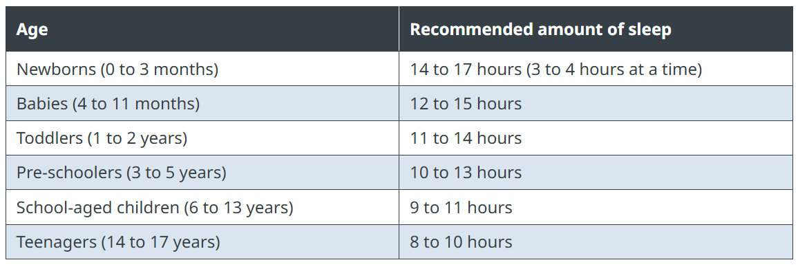
Sleep is a very important part of your child’s mental and physical health because it allows your child’s mind and body to rest and recover. There are many things you can do to help your child get good quality sleep as often as possible.
I have included this chart to help you with how much sleep your child ideally needs.
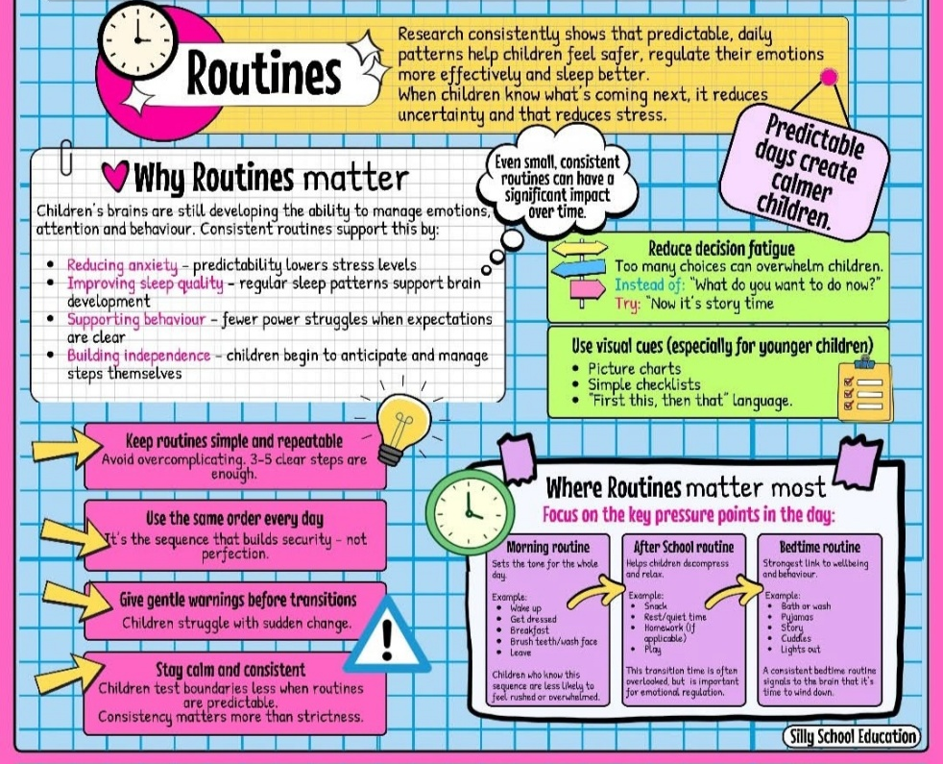

The following information is to guide you through why sleep routines are important, why they help, what the benefits are and extra support should you need it.

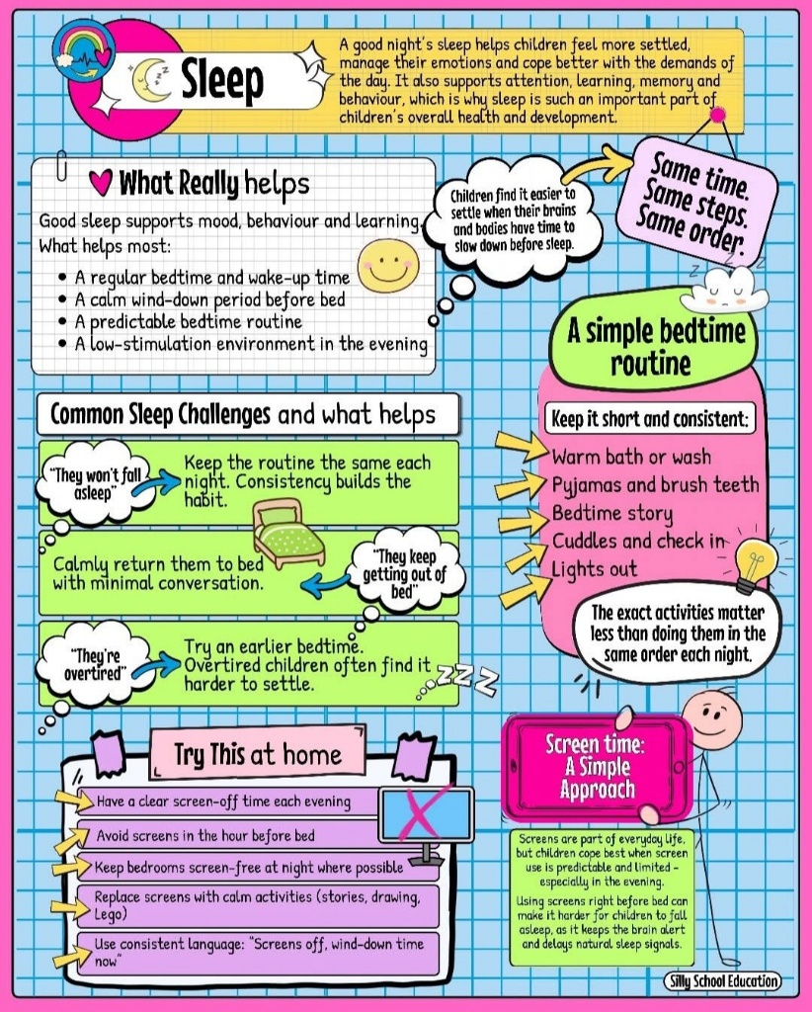
Not getting enough sleep each night can have negative consequences for your child. These cannot always be erased with extra sleep the next night. Over time, not getting enough quality sleep each night can produce a range of behavioural, mental and emotional symptoms.
When your child owes their mind and body sleep, this is called sleep debt. A large sleep debt (not getting enough sleep for many nights in a row) can result in your child feeling mentally exhausted.

Physical symptoms
- Finding it difficult to wake up in the morning
- Falling asleep after being woken up and needs you to wake them again repeatedly
- Yawning often during the day
- Complaining of feeling tired or wanting to nap during the day
- Preferring to lie down during the day, even if it means missing activities with friends or family
- Falling asleep or seeming drowsy at school or at home during homework

Cognitive (mental) symptoms
- Lacking interest, motivation and attention for everyday tasks
- Increased forgetfulness
- Difficulty learning new information

Emotional symptoms
- Increased moodiness and irritability
- Increased impulsivity
- Increased stress throughout the day

Books are an easy way to introduce new routines and are reasonably priced.
Websites can provide a wealth of information too.

- The sleep charity.

- NHS

- Young Minds

- NSPCC

Always here and happy to help
Ms Winterton x

