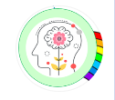
Mindful about Mental Health.
How to Talk about Mental health with your Child

Mental health awareness week – 11th – 17th May 2026

This month, I wanted to share information about how to talk about mental health with your child. I am sharing information from the Anna Freud website

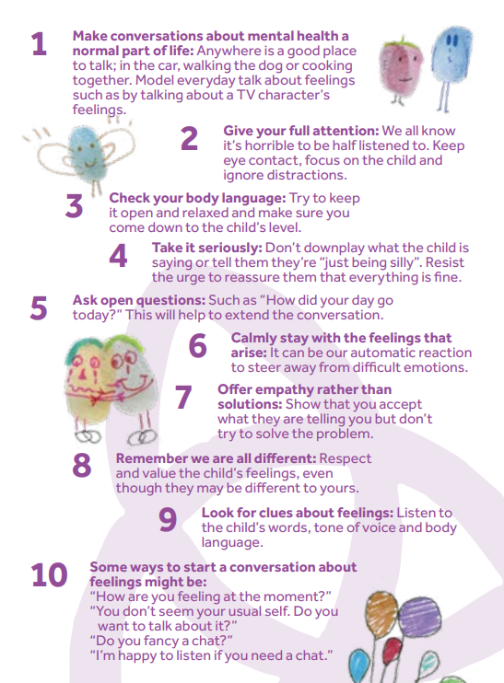
This document (see the link below) shares brilliant tips for making mental health a topic of conversation at home without the embarrassment or uncomfortable feelings. Mental health should not be a taboo subject and should be encouraged and discussed freely by all members of your family.

"Demonstrate how we can help children express their feelings, respond appropriately, and prevent small problems from snowballing into bigger ones."

tmh-parent-leaflet-final-web-updated-by-ed-april-2020.pdf

Services for Families | Anna Freud

Always here and happy to help,
Ms Winterton x

