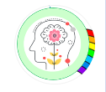
Mindful about Mental Health.
March – Loneliness

What is loneliness?
‘Loneliness is ‘a subjective, unwelcome feeling of lack or loss of companionship. It happens when we have a mismatch between the quantity and quality of social relationships that we have, and those that we want’- What Works Wellbeing

In other words, loneliness is the negative feeling we experience when the relationships we have do not match up to those we would like to have. This may be because we would like more people to talk to or because our relationships are not as meaningful as we would like.

Being lonely is not the same as being isolated. Isolation is about the number and type of social connections we have, not about how we feel those relationships are going. Being socially isolated could mean having few social relationships, while loneliness reflects our feelings about those relationships. A person could be isolated but not lonely or could feel lonely while being surrounded by other people. We shouldn’t try to assess how someone feels about their relationships just by counting how many friends or connections they have. Instead of doing that, we can ask them to tell us directly how satisfied they are with those connections.
Before Covid, it was reported that 11% of 10-15 year olds felt lonely often or always – that is 3 in a class of 30.
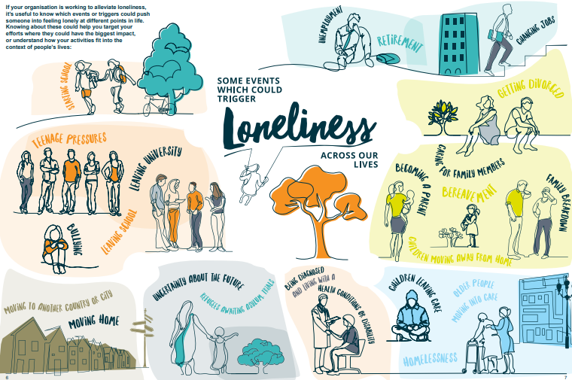

Support
The Mix – a UK-based charity that provides free, confidential support for young people under 25. Young people can get support from the trained team, either by phone, webchat, or email
Shout 85258 – a free, confidential, 24/7 text-messaging support service.
Samaritans – a UK-based charity that provides free support anytime, from any phone. Call free on 116 123 or email jo@samaritans.org
Parents Helpline | Mental Health Help for Your Child | YoungMinds

Support for parents and caregivers
Young Mind’s Parent Helpline and Webchat provides advice and support for parents and caregivers who are worried about a child or young person.

In addition to this resources and support from other agencies, please speak to us in school if you are concerned about a child. You can message me, Mrs Morley (parent support worker) or your class teacher via Class Dojo.

Always here and happy to help
Ms Winterton x

