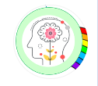
Mindful about Mental Health.
February – Belonging

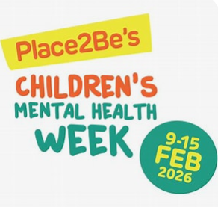
February is Children’s Mental Health week! 9th-15th February, Farmilo will be celebrating children’s mental health but the whole family can get involved!

This year’s theme is ‘This is my Place!’ which is all
about belonging.

Belonging to a family, a school
or the community. Having a sense of belonging is
important for everyone as it increases our connectivity to other people and improves our wellbeing and in turn – our mental health.

A strong sense of belonging in childhood is crucial for emotional security, social development and overall wellbeing. It influences children’s confidence, creativity and their relationships with other children and adults.

Bing Videos Here is a short video that will tell you all about the theme of this year’s themed week.

It would be great if you could join in at home and embed the ethos of ‘belonging’
If you and your family carry out some of the activities shared, please send photos to your class teacher and or me so we can see what you’ve been up to!

families-and-communities-pack-childrens-mental-health-week-2026.pdf
By clicking on the link above, you can join in at home and with your family.

Also on Place2be website, you can find parenting advice from their child mental health experts. Practical tips to support your child’s wellbeing and behaviour.

Place2Be: Parenting Smart - Articles

Always here and happy to help
Ms Winterton x

