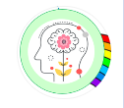
Mindful about Mental Health.
January – Mental Health in the New Year



The new year can be a time for reflecting on the previous year but it can also have a significant impact on our mental health – offering opportunities for renewal, challenges and expectations. Please click on this link to the Mind website find out more about how you can support your mental health in the new year and through 2026.
5 Simple Steps to Boost Mental Wellness in New Year
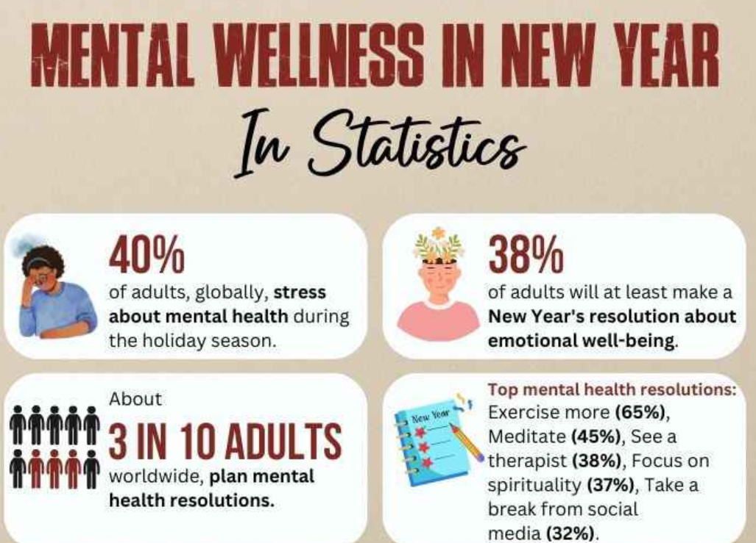

Always here and happy to help
Ms Winterton x

