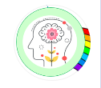
Mindful about Mental Health – Emotional Literacy
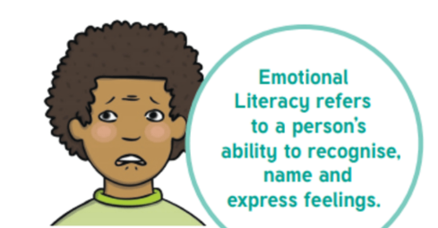
What is emotional literacy?
Emotional literacy is the term used to describe the ability to name, recognise and communicate feelings. Children need to be taught this key skill to ensure that they can understand and process their feelings in a healthy way.
Emotional literacy promotes self-awareness of how we understand feelings and emotions, as well as our reactions to them. This knowledge enables us to calm ourselves if we are feeling overwhelmed and reassure ourselves in unfamiliar situations. Children need support to learn these skills to become, and remain, emotionally healthy throughout their life.
Emotional literacy isn’t just about being able to use speech to communicate feelings and emotions. Some children may need to use visual aids to express their feelings or to understand the feelings of others.

Practical tips to help your child develop emotional literacy:

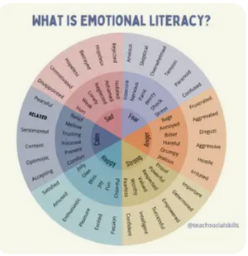
Model labelling emotions – Accept and label your own emotion and your child’s emotions. For much younger children, “You seem very excited right now” or “You’re crying, are you feeling sad?” This helps the child to understand the word and what it might look like.

Encourage Expression – Encourage children to express their emotions positively. Ask questions like “How can you show me you’re angry without kicking?” This will help them think of different ways of expressing emotions.

Practise Emotional Regulation as a family – Teach your children to manage their emotions through activities like breathing exercises, yoga, mindfulness (as a whole school approach, Farmilo carry out lots of these activities in school throughout the year.) Please message me if you need any support or help in finding these resources.
These activities help to reduce stress and develop emotional stability. It’s also very good for adults too so it’s easily a family activity!
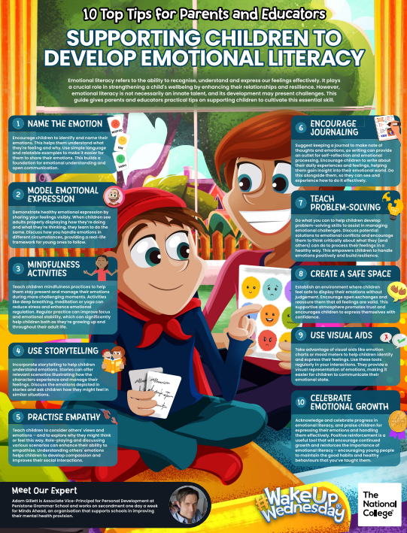

Always here and happy to help.
Ms Winterton x

