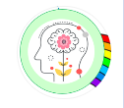
Mindful about Mental Health
Mental Health & Well-being - how to promote it.

For a child’s development, mental health and overall happiness, a stable well-being is essential. This requires support from parents, carers, school and the wider community. Well-being encompasses their mental, emotional and physical health. Promoting it can help children develop resilience, cope with challenges and build positive relationships. Mental health plays a key role in over all well being and negative experiences can adversely affect a child’s mental state whilst positive experiences can enhance it.

Strategies to promote well-being –
- Open communication – encourage childre4n to express their feelings and thoughts. Regularly ask about their day and talk about yours too. This will get them used to discussing their emotions and know that it is “OK”
- Create an open and supportive environment – A space where children feel valued and listened to. Show an interest in their lives and activities. This will help them feel supported and connected.
- Healthy habits – Regular exercise, healthy eating of a balanced diet and a good sleep routine. These have a huge part to play in your child’s well-being.
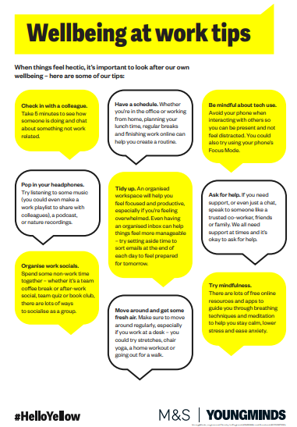
Everyone’s well-being is important. Here are a few tips for your own wellbeing.

For more information on mental health & well-being and how to promote it, please visit the NSPCC website for more advice and support.
Promoting mental health and wellbeing | NSPCC Learning

Here are a few short videos to watch with your child. Talking about well-being together as a family is a good habit to get into.
Five ways to wellbeing - BBC Teach

Always here and happy to help.
Ms Winterton x

