SCHOOL MUSIC DEVELOPMENT PLAN

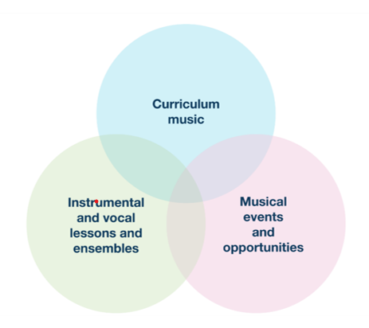

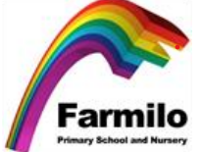

Focus area 1: The Curriculum
Not yet in place | Emerging | Estbalished | Embedded
Music is delivered ‘ad hoc’ and not in every year group. Some groups of students are unable to access the music curriculum.  Progress over time is not measured or celebrated.  There are limited resources for teaching. | Music is a timetabled subject, with schemes of work and assessment in place. All students are able to access this curriculum in all year groups.  Students engage with schemes of work and build areas of musical interest and growing skill.  Pupils with additional needs are able to participate and engage with music-making.  There is adequate teaching space and resources available. | The music curriculum is at least as ambitious as the national curriculum. Curriculum sequencing is clear.  Good progress is demonstrated by secure and incremental learning of the technical, constructive, and expressive aspects of music, developing musical understanding.  Pupils with additional needs are able to participate and progress well (supported by technology, tools and adapted instruments).  Space and resources allow breadth of curriculum for all students, including music technology. | Curriculum goes beyond level of the national curriculum, seeking to address social disadvantage by addressing gaps in knowledge, skills and experiences (i.e. concerts, live events).

Currently the curriculum best fit is: Emerging.
The reasoning behind this is due to currently working on still embedding a new scheme throughout the whole school, ensuring it is being taught acorss key stages reflecting the long term plans and the needs of the children at Farmilo Primary School.

Actions for the curriculum:
Resoucres – Continuous update of reosurces.  Where the resources are not avilable looking at alternatives in order for the children to still get the maxium  experince from the unit. | Being reviewed at the end of Spring.  Beaters have been ordered.
Progress – ensuring the 2 year cycle is being followed and is enabling children with approprate progression and  coverage. | This will be an ongoing review.

Focus area 2: Instrumental and Vocal Lessons and Ensembles
Not yet in place | Emerging | Estbalished | Embedded
Singing takes place infrequently in school.  There are opportunities to perform for a small number of pupils. There may be barriers to participation.  Facilitation of one to one and small group tuition is limited or inconsistent. | Singing and vocal work is frequent, varied and all students are engaged All pupils, including the most disadvantaged and pupils with SEND, have an opportunity to perform regularly. In-school musical events take place at least termly.  The school facilitates one to one and group tuition through Severn Arts. Pupils and families facing the largest barriers are given support to engage in music learning as part of, and beyond, the curriculum. | Singing and vocal work is embedded into the life of the school and into every child’s experience, drawing on a wide range of high-quality, age-appropriate repertoire and developing musicianship. All staff in the school are able to support singing.  Music performance is a prominent component of school life from an early age; music is performed in assemblies and events such as sports day and open evenings alongside in-school events.  The overall provision is diverse, valuing all musical styles, genres and traditions equally; this is reflected in the clubs and enrichment programme and drawing on the skills, talents and interests of staff and local stakeholders through specialist tuition. A large proportion of students are involved. | A full, long-term singing strategy is in place that ensures progression for all students.  The school tracks and monitors engagement in enrichment, ensuring that there is a large proportion of students able to engage in music in and out of school. Provision is targeted, demonstrating wider impact.  Co-curricular music is supported by the school and time is allocated for staff to run these groups successfully  Students are able to take leadership roles in musical opportunities.  The school is actively involved in national, largescale events.

Currently the curriculum best fit is: Established.

Actions for instruemnetal and vocal lessons and ensembles:
Choir - Research and look into what wider social events choir can be involved in. | Choir are going to attend young voices.
Leadership roles – Implementing leadership roles for each Key Stage.  These leaders will be responsible for warm ups during singing assemblies, helping to get equipment  for music etc. | Being reviewed in order to be prepared for Spring.

Focus area 3: Musical Events and Opportunites
Not yet in place | Emerging | Estbalished | Embedded
Small-scale performance takes place in the community, building on existing school links.  Some parents and carers support music-making in the school by attending events. | Community links are established with the music team; regular events take place throughout the school year.  Parents and carers actively support music making, through support at events and through home learning. | Meaningful partnerships are established with the community and a large proportion of students engage with this, understanding that there are clear civic and moral benefits to doing so (link to personal development and character education).  The views of pupils, parents and carers have been considered when developing music provision.  The school has links to the wider music eco-system and actively encourages students to join Severn Arts Ensembles. Students benefit from interactions with those working in the profession. | There is a co-ordinated programme of community events, planned in partnership with stakeholders. These events giving students the opportunity to engage in volunteering.  Parents/carers and the wider community are actively involved in school music making  The school has established connections with the next stages of musical education so that progression routes can be signposted meaningfully

Currently the curriculum best fit is: Emerging,

Actions for musical events and opprtunites:
Pupil voice – speak to the pupils and gauage an idea of what events and opportunites interest the children. | Choir are going to sing at the hospital and the care home.  Spring – pupil voice interviews to be conducted.
1-1 tuition – research and make contact with inspire music. | Being reviewed in order to be prepared for later in year.  Rock steady have been in – awaiting interest.

