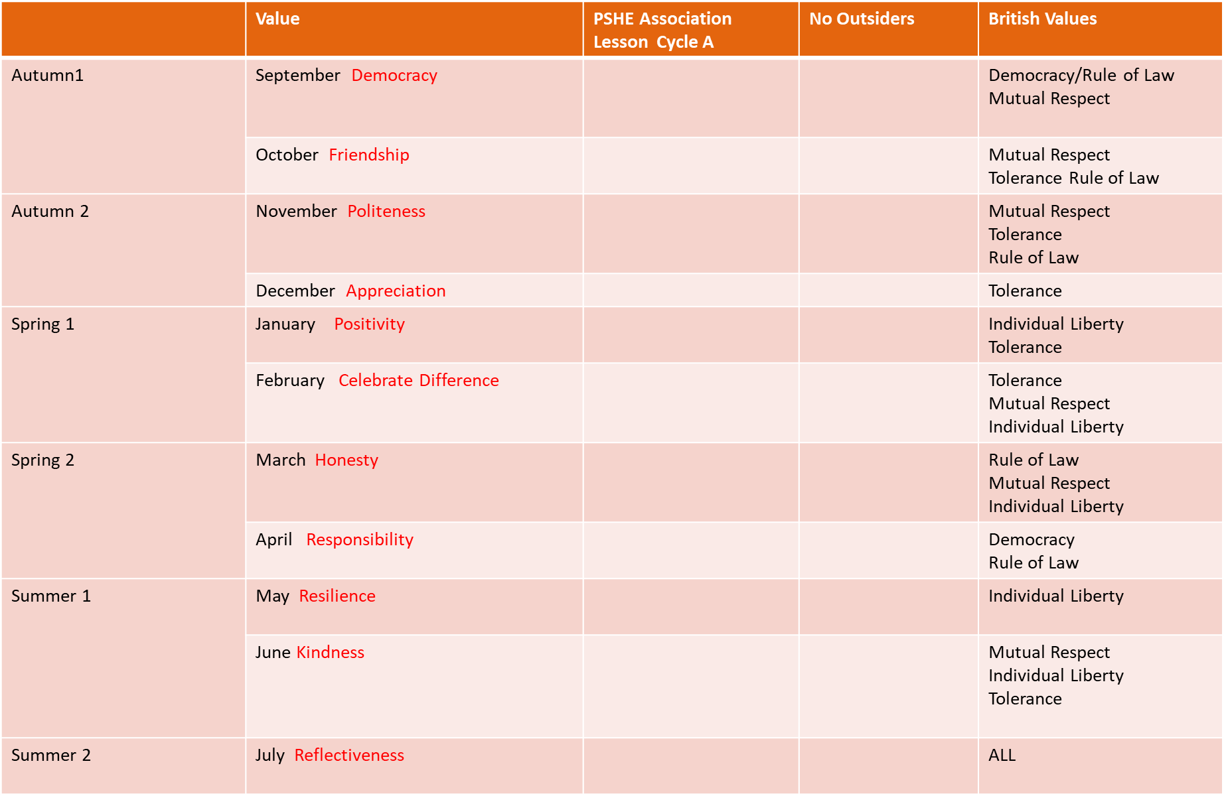
Team
Diverse Britain
Think positive
Digital wellbeing
One world
Growing up
What the Jackdaw saw- Julia Donaldson
All are welcome-
Alexandra Penfold
How to be a lion- Ed Vere
Can I join your club?-
John Kelly
The great big book of families- Mary Hottman
Amazing- Steve Anthony

